**MYSQL**

**DAY-2**

**Creating DB on workbench and reverse engineering**

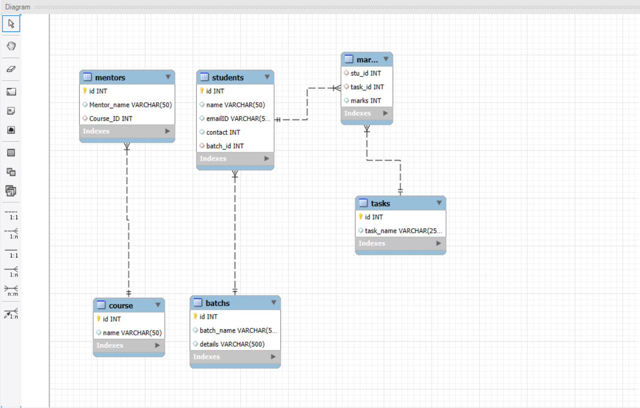

**CREATE TABLE batchs (**

**id int primary key,**

**batch_name varchar(50),**

**details varchar(500));**

**DESCRIBE batchs;**

**INSERT INTO batchs (id,batch_name,details) values**

**(1,'FSD60WD','Fullstack Developement'),**

**(2,'DS60WD','Data Science'),**

**(3,'FSD50WD','Fullstack Developement'),**

**(4,'FSD50WE','Fullstack Developement');**

**SELECT * FROM batchs;**

**CREATE TABLE students (**

**id int primary key,name varchar(50),emailID varchar(50),contact int,batch_id int , foreign key(batch_id) references batchs(id)**

**);**

**describe students;**

**INSERT INTO students (id,name,emailID,contact,batch_id) values(101,'Priyanka','priyanka@gmail.com',63741,1),**

**(102,'Swathi','swathi@gmail.com',5854,2),(103,'Bala','bala@zoho.in',636982,3),(104,'Vishal','vishal@gmail.com',68426,4);**

**select * from students;**

**CREATE TABLE course(id int primary key,name varchar(50));**

**INSERT INTO course(id,name) values(1001,'Front end'),(1002,'Back end'),(1003,'SQl');**

**select * from course;**

**CREATE TABLE Mentors(id int primary key,Mentor_name varchar(50),Course_ID int ,foreign key(Course_id) references course(id));**

**INSERT INTO Mentors(id,Mentor_name,Course_ID) values(1,'amutha',1003),(2,'shan',1001),(3,'ak',1002);**

**SELECT * FROM Mentors;**

**CREATE TABLE tasks(id int primary key,task_name varchar(250));**

**INSERT INTO tasks(id,task_name) values(1,'Basic JS'),(2,'Basic HTML'),(3,'Basic CSS');**

**CREATE TABLE marks(stu_id int,task_id int,marks int ,foreign key(stu_id) references students(id),foreign key(task_id) references tasks(id));**

**INSERT INTO marks(stu_id,task_id,marks) values(101,1,9),(102,2,8),(103,1,10),(104,2,3);**

**SELECT * FROM marks;**